Assignment No. 3

1. Create a database named StudentManagement

create database StudentManagement;

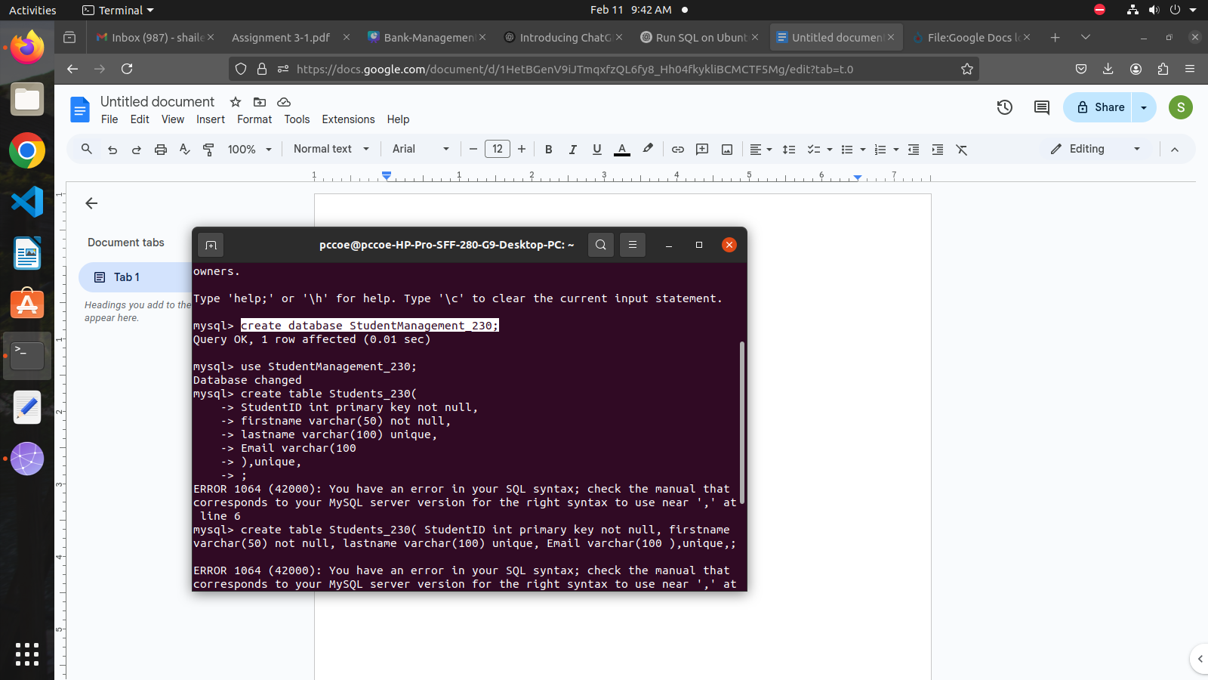

2. Define the following tables with appropriate constraints:

Table 1: Students

create table Students_230(

StudentID int primary key not null,

Firstname varchar(50) not null,

Lastname varchar(100) unique,

Email varchar(100) unique,

DOB date not null,

CourseID int,

foreign key (CourseID) references Courses(CourseID)

);

Table 2: Courses

create table Courses(

CourseID int primary key not null,

CourseName varchar(100) not null unique,

Credits int default 3

);

3. Insert records into the tables while ensuring the constraints are not violated.

-- Inserting 3 random courses.

insert into Courses (CourseID, CourseName, Credits) values

(1, 'Introduction to Computer Science', 3),

(2, 'Data Structures and Algorithms', 4),

(3, 'Database Management Systems', 3);

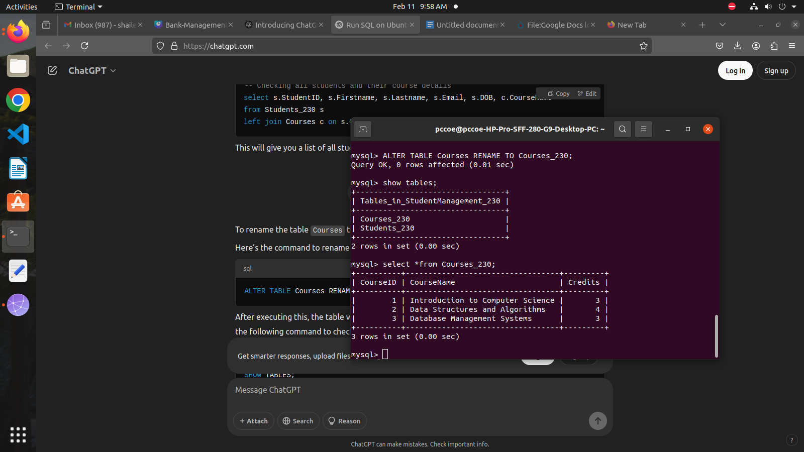

-- Inserting 6 random students

insert into Students_230 (StudentID, Firstname, Lastname, Email, DOB, CourseID) values

(101, 'Aarav', 'Sharma', 'aarav.sharma@example.com', '2001-05-12', 1),

(102, 'Isha', 'Patel', 'isha.patel@example.com', '2000-08-21', 2),

(103, 'Ravi', 'Verma', 'ravi.verma@example.com', '1999-11-30', 3),

(104, 'Priya', 'Gupta', 'priya.gupta@example.com', '2002-03-14', 1),

(105, 'Vikram', 'Reddy', 'vikram.reddy@example.com', '2000-01-25', 2),

(106, 'Ananya', 'Nair', 'ananya.nair@example.com', '1998-07-07', 3);

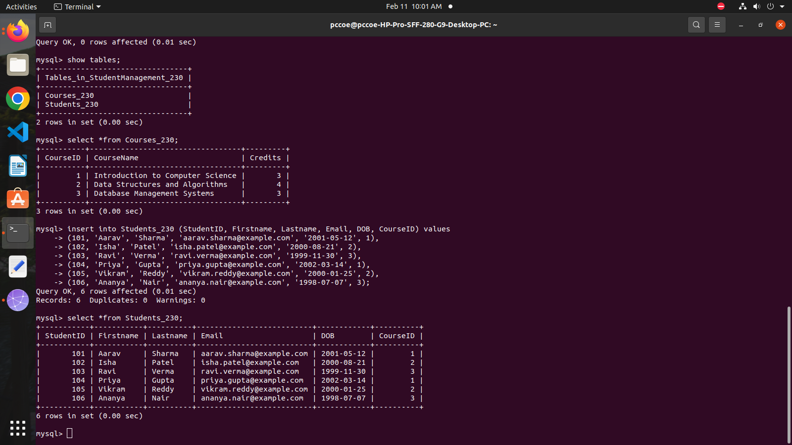

4. Test the Constraints

1. Test 1: Insert a NULL value into a NOT NULL column.

Attempting to insert NULL into the 'Firstname' column (NOT NULL constraint violation)

insert into Students_230 (StudentID, Firstname, Lastname, Email, DOB, CourseID)

values (107, NULL, 'Singh', 'singh@example.com', '2003-02-15', 1);

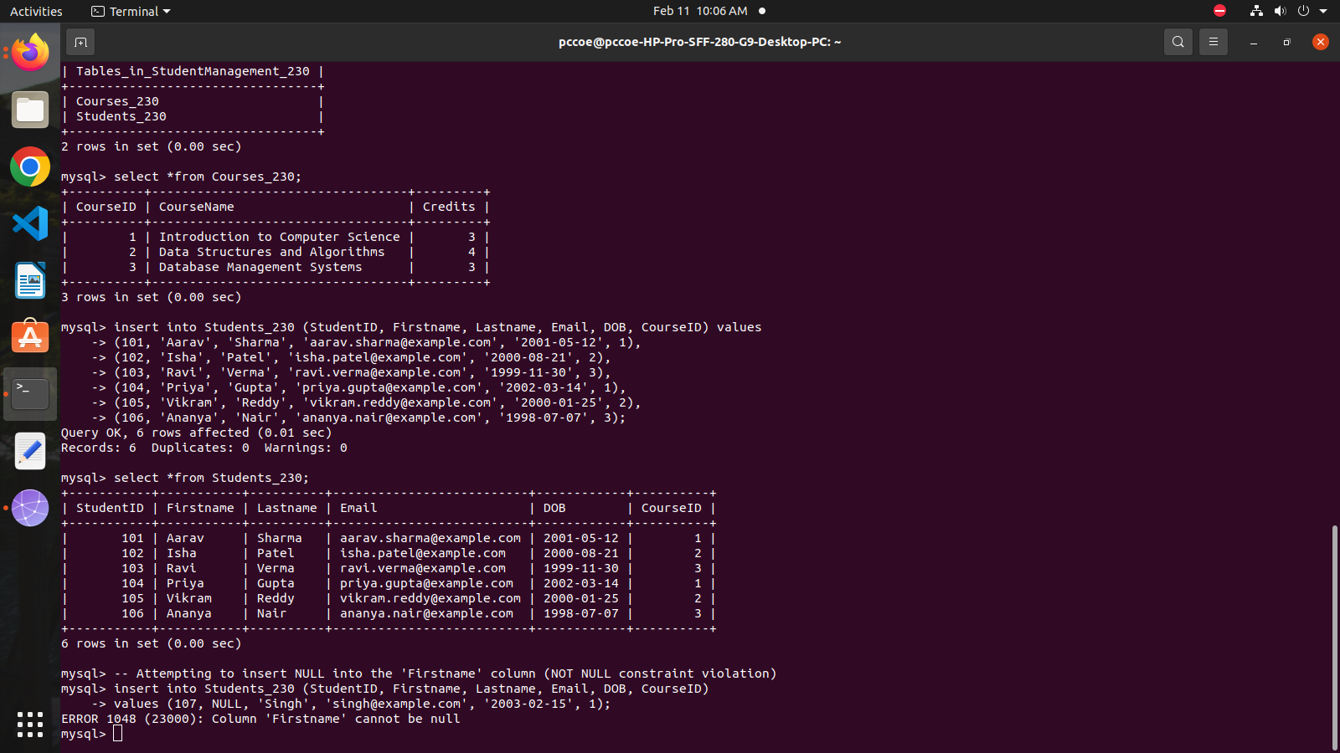

2. Test 2: Insert a duplicate value in the UNIQUE column.

Attempting to insert a duplicate Email (UNIQUE constraint violation)

insert into Students_230 (StudentID, Firstname, Lastname, Email, DOB, CourseID)

values (108, 'Ankit', 'Kumar', 'aarav.sharma@example.com', '2001-05-12', 2);

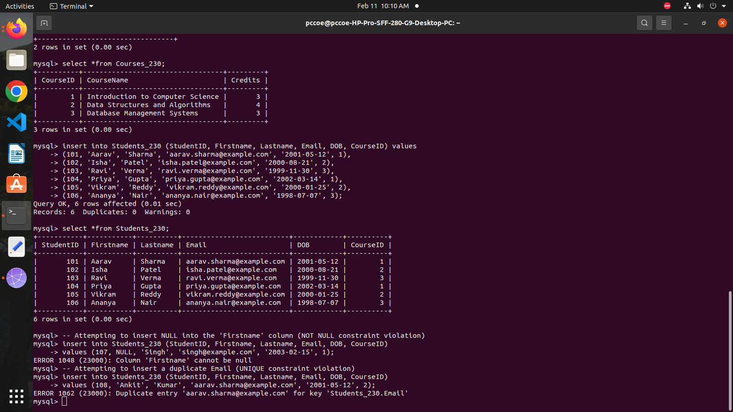

3. Test 3: Insert a record with an invalid FOREIGN KEY reference.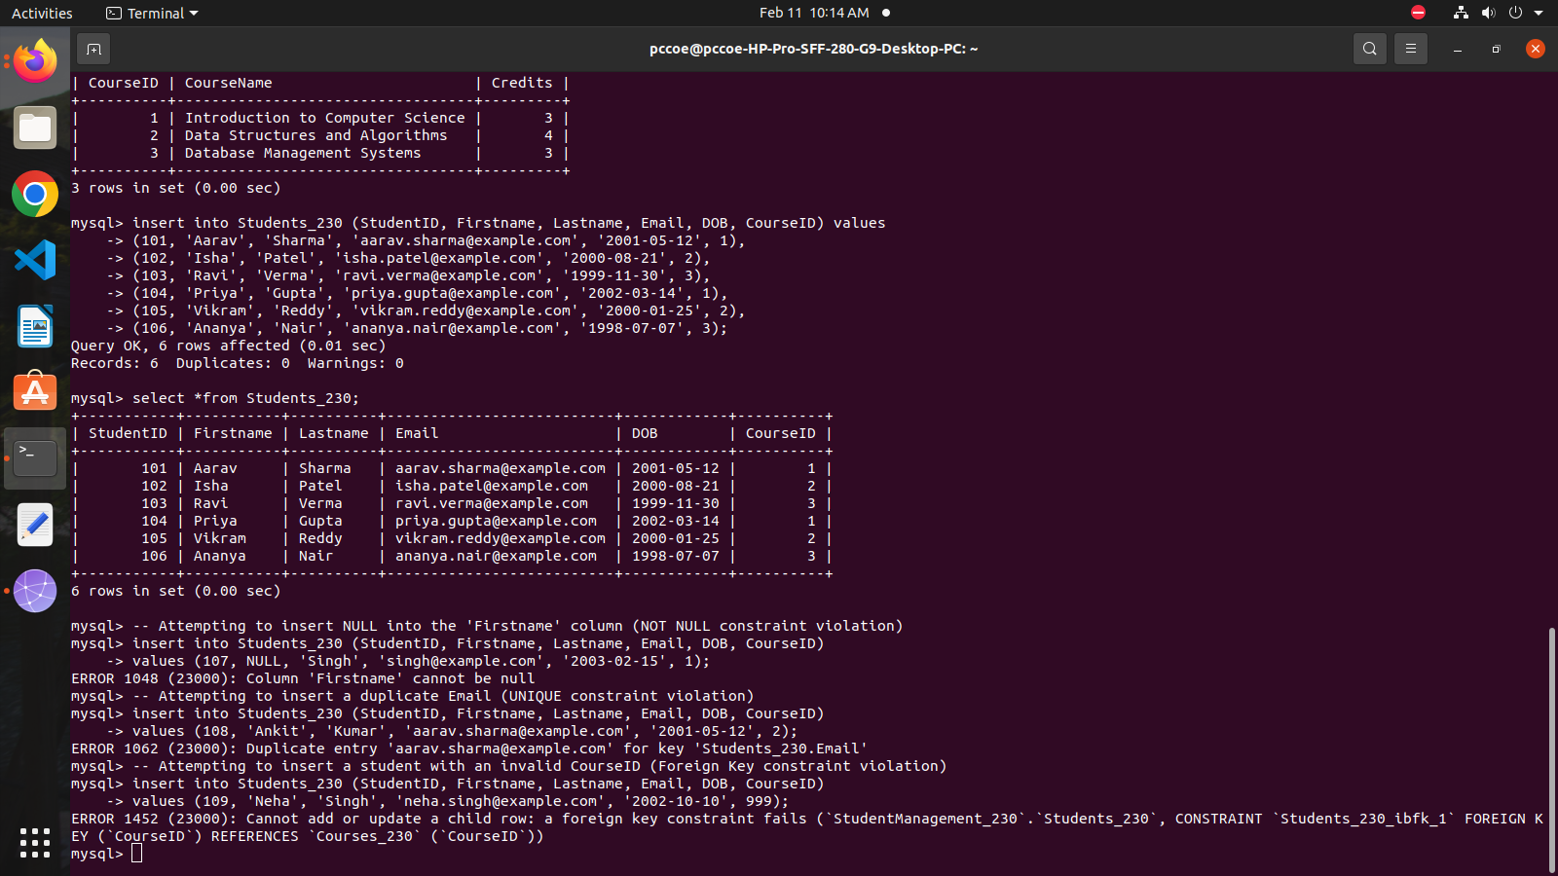

5. Attempt following questions:

1. Write a query to display the names of students who were born after the year 2000.

select Firstname,Lastname from Students_230

where year(DOB) > 2000;

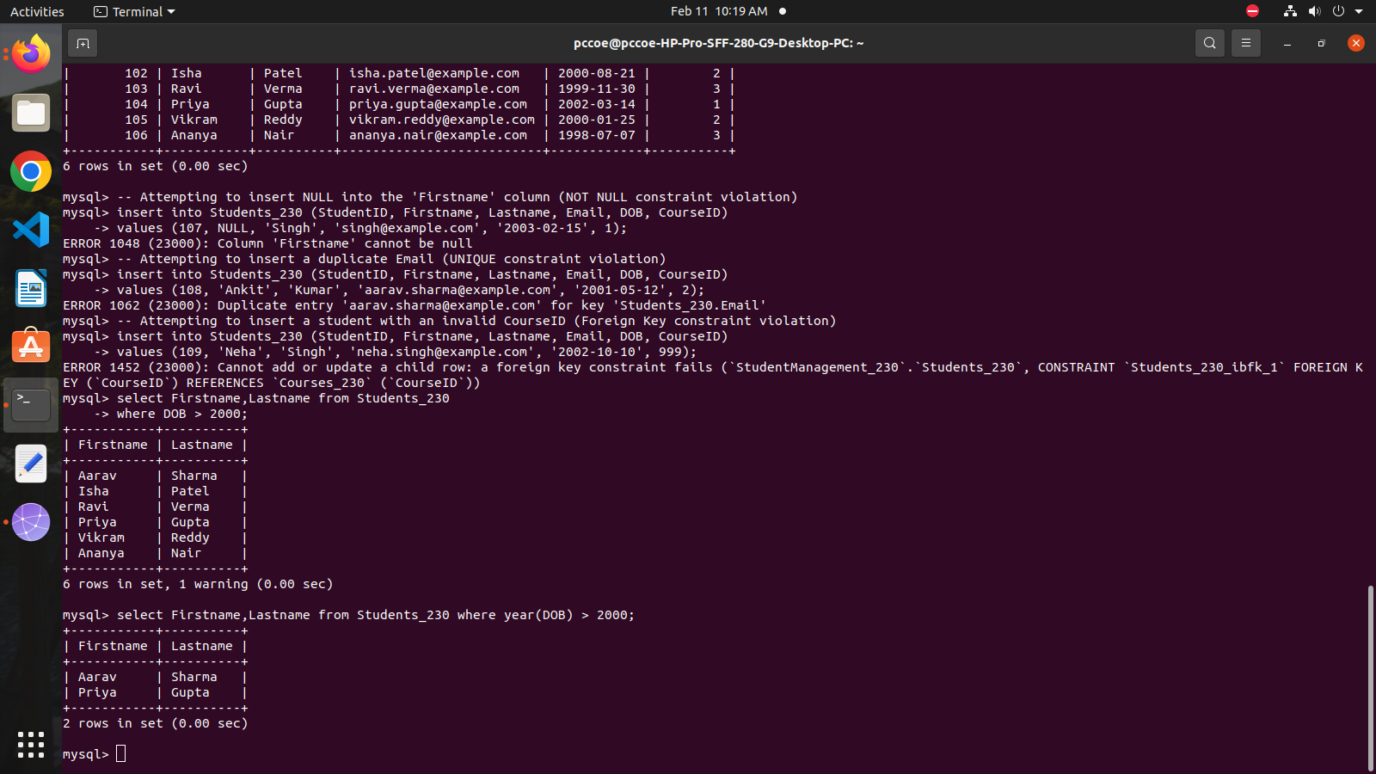

2. Write a query to update the course credits for "Computer Science" to 4.

update Courses_230

set Credits = 4

where CourseName = 'Introduction to Computer Science';

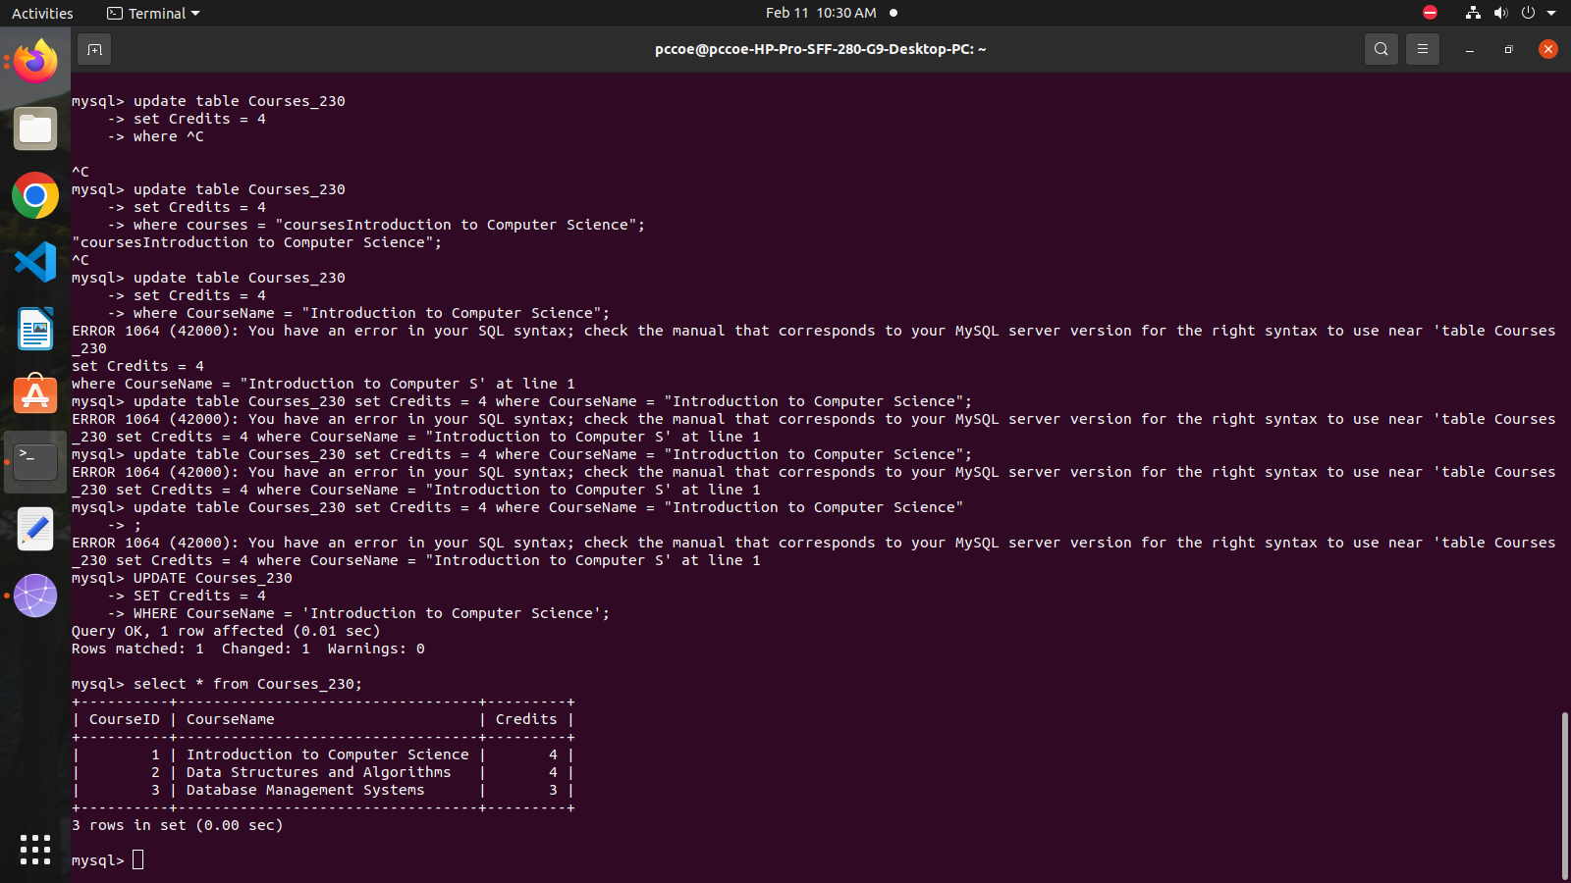

3. Write a query to delete a student record whose email is ''[isha.patel@example.com](mailto:isha.patel@example.com)''.

DELETE FROM Students_230 WHERE Email = '[isha.patel@example.com](mailto:isha.patel@example.com)';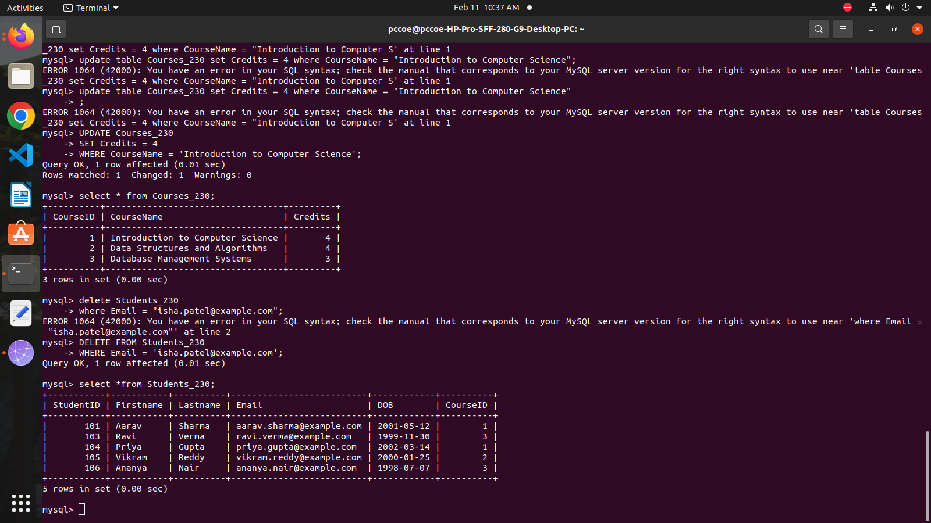

4. Write a query to find students who are not enrolled in any course.

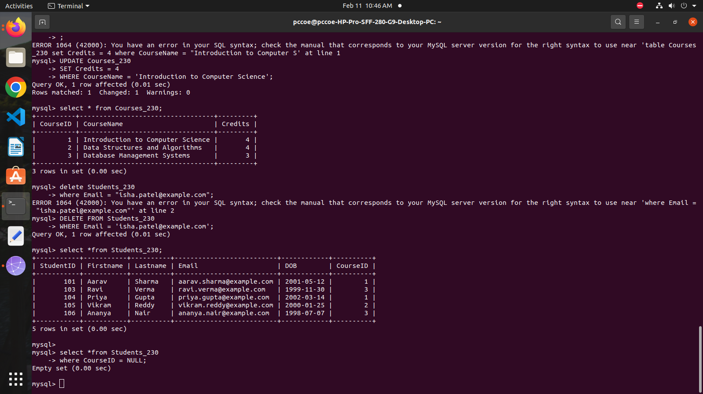

5.Test the UNIQUE constraint by inserting a duplicate email into the Students table.

INSERT INTO Students_230 (StudentID, Firstname, Lastname, Email, DOB, CourseID)

VALUES (110, 'Arjun', 'Chaudhary', 'aarav.sharma@example.com', '2001-06-10', 2);

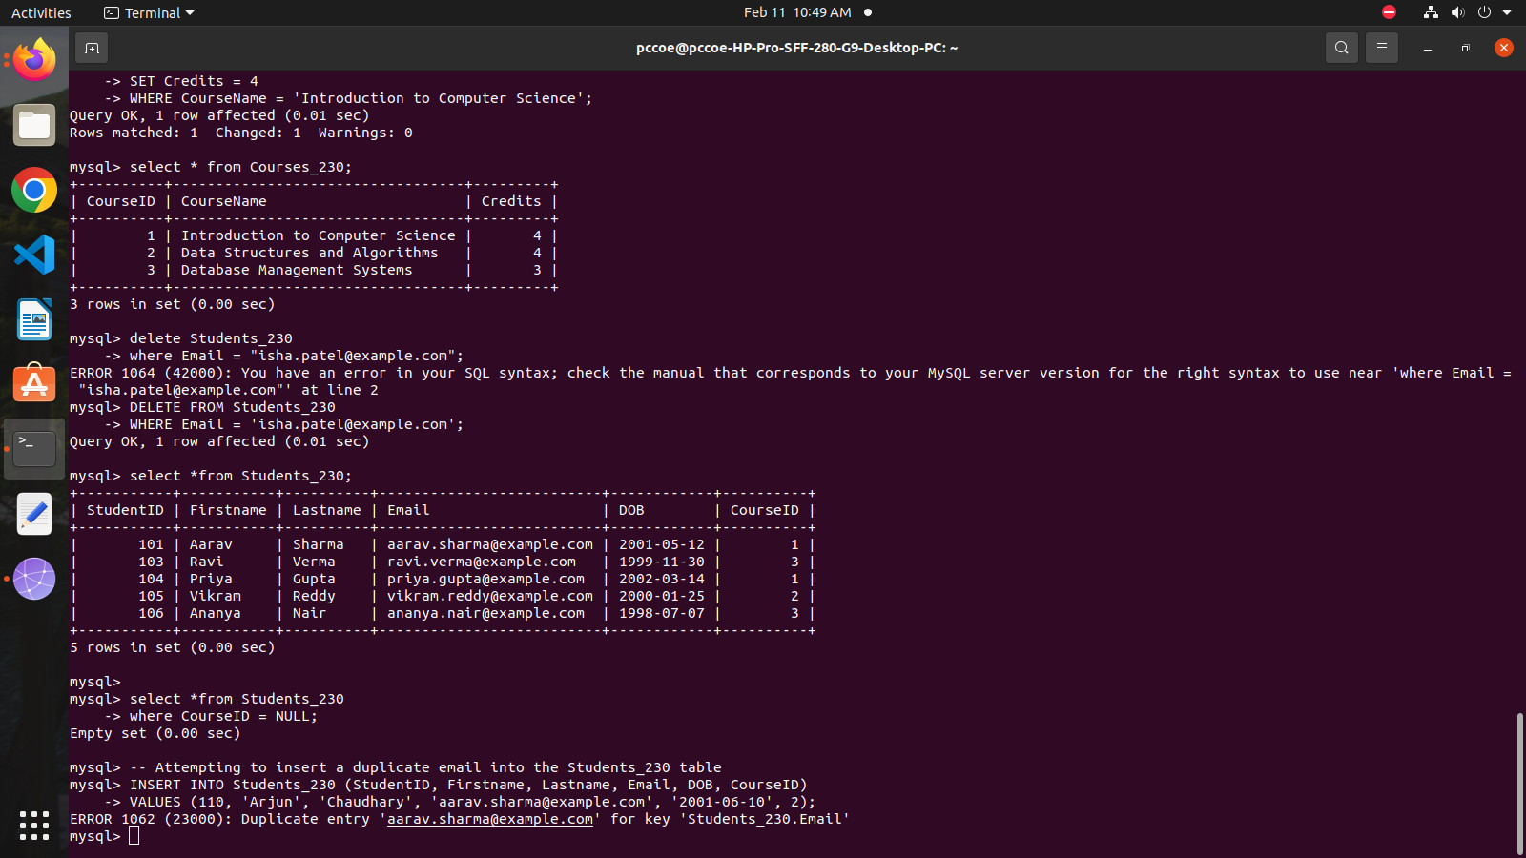

6. Test the FOREIGN KEY constraint by inserting a student with a CourseID

that does not exist in the Courses table

INSERT INTO Students_230 (StudentID, Firstname, Lastname, Email, DOB, CourseID)

VALUES (111, 'Ravi', 'Kumar', 'ravi.kumar@example.com', '2002-12-15', 999);

